Aim: To understand the process of convolution over the image and apply over the classification problem
IDE: Google Collab

Theory:
Convolutional Neural Networks (CNN) are complex feed-forward neural networks. CNNs are used for image classification and recognition because of their high accuracy. There are three types of layers in a convolutional neural network: I. Convolutional layer II. Pooling layer III. Fully connected layer. Each of these layers has different parameters that can be optimized and performs a different task on the input data.

What is a Pooling Layer?
The pooling layer is responsible for reducing the spatial size of the Convolved Feature. This is to decrease the computational power required to process the data through dimensionality reduction. There are two types of Pooling i. Average Pooling. ii. Max Pooling returns the maximum value from the portion of the image covered by the Kernel. On the other hand, Average Pooling returns the average of all the values from the portion of the image covered by the Kernel. Max Pooling also performs as a Noise Suppressant. It discards the noisy activations altogether and also performs de-noising along with dimensionality reduction. On the other hand, Average Pooling simply performs dimensionality reduction as a noise-suppressing mechanism. Hence, we can say that Max Pooling performs a lot better than Average Pooling.

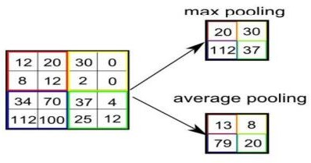

What is a Convolutional Layer?
Convolutional layers are the major building blocks used in convolutional neural networks. A convolution is the simple application of a filter to an input that results in an activation. Repeated application of the same filter to an input results in a map of activations called a feature map, indicating the locations and strength of a detected feature in an input, such as an image. A convolutional layer contains a set of filters whose parameters need to be learned. The height and weight of the filters are smaller than those of the input volume. Each filter is convolved with the input volume to compute an activation map made of neurons.

What is a Fully Connected Layer?
A fully connected layer that takes the output of convolution/pooling and predicts the best label to describe the image. We have three layers in the full connection step i. Input layer ii. Fully-connected layer III. Output layer
Input Layer: It takes the output of the previous layers, “flattens” them, and turns them into a single vector that can be an input for the next stage.
Fully Connected Layer: It takes the inputs from the feature analysis and applies weights to predict the correct label.
Output Layer: It gives the final probabilities for each label.
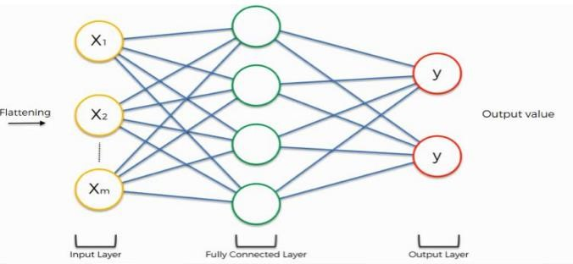
ReLU Layer: ReLU is an activation function. Rectified Linear Unit (ReLU) transform function only activates a node if the input is above a certain quantity; when the input is below zero, the output is zero, but when the input rises above a certain threshold, it has a linear relationship with the dependent variable. The main aim is to remove all the negative values from the convolution. All the positive values remain the same, but all the negative values get changed to zero.

Methodology:
- Load the basic libraries and packages
- Load the dataset
- Analyze the dataset
- Normalize the data
- Pre-process the data
- Visualize the Data

- Write the CNN model function
- Write the Cost Function
- Write the Gradient Descent optimization algorithm
- Apply the training to the dataset to minimize the loss
- Observe the cost function vs iterations learning curve

Program (Code):
#import libraries
import numpy as np
import pandas as pd
import matplotlib.pyplot as plt
import keras
from keras.datasets import fashion_mnist
import keras.models as models
import keras.layers as layers
from keras import regularizers
from keras.layers import Dropout
import tensorflow as tf
from tensorflow.keras.models import Sequential, Model
from tensorflow.keras.layers import Dense,Activation,Flatten,Dropout,Conv2D, MaxPooling2D, LeakyReLU
from tensorflow.keras.utils import to_categorical #for the categorical data
#import the dataset #x: Images and Y: labels of the images
(train_X,train_Y),(test_X,test_Y)=fashion_mnist.load_data()
plt.imshow(train_X[0])
print(train_Y[0])
classes=np.unique(train_Y)
nClasses=len(classes)
print(classes)
print(nClasses)
train_X=train_X.reshape(-1,28,28,1)
test_X=test_X.reshape(-1,28,28,1)
#converting the values of the pixels from 0-1
#type-conversion
train_X=train_X.astype('float32')
test_X=test_X.astype('float32')
train_X=train_X/255
test_X=test_X/255
train_Y_one_hot=to_categorical(train_Y)
test_Y_one_hot=to_categorical(test_Y)
train_Y[0]
train_Y_one_hot[0]
#Model training task
from sklearn.model_selection import train_test_split
train_X,valid_X,train_label,valid_label=train_test_split(train_X,train_Y_one_hot,test_size=0.2,random_state=13)
train_X.shape,valid_X.shape,train_label.shape,valid_label.shape
#Basic CNN model Develop
#Regularization and Dropout
#2nd CNN MODEL DEVELOPMENT
batch_size=64
epochs=20
num_classes=10
model=tf.keras.Sequential()
#1st hidden layer
model.add(tf.keras.layers.Conv2D(32,(3,3),activation="linear",padding='same'))
model.add(tf.keras.layers.LeakyReLU(alpha=0.1))
model.add(tf.keras.layers.MaxPooling2D(pool_size=(2,2),padding='same'))
#2nd hidden layer
model.add(tf.keras.layers.Conv2D(64,(3,3),activation="linear",padding='same'))
model.add(tf.keras.layers.LeakyReLU(alpha=0.1))
model.add(tf.keras.layers.MaxPooling2D(pool_size=(2,2),padding='same'))
#3rd hidden layer
model.add(tf.keras.layers.Conv2D(128,(3,3),activation="linear",padding='same'))
model.add(tf.keras.layers.LeakyReLU(alpha=0.1))
model.add(tf.keras.layers.MaxPooling2D(pool_size=(2,2),padding='same'))
model.add(tf.keras.layers.Flatten())
model.add(tf.keras.layers.Dense(128,activation='linear'))
model.add(tf.keras.layers.LeakyReLU(alpha=0.1))
model.add(tf.keras.layers.Dense(num_classes,activation='softmax'))#output final layer
model.compile(loss=tf.keras.losses.categorical_crossentropy,optimizer=tf.keras.optimizers.Adam(),metrics=['accuracy'])
model_train=model.fit(train_X,train_label,batch_size=64,epochs=20,verbose=1,validation_data=(valid_X,valid_label))
testing_evaluation=model.evaluate(test_X,test_Y_one_hot)
testing_evaluation #loss,accuracy
model_train.history
accuracy=model_train.history['accuracy']
val_accuracy=model_train.history['val_accuracy']
loss=model_train.history['loss']
val_loss=model_train.history['val_loss']
epochs=range(len(accuracy))
plt.plot(epochs,accuracy,label='training accuracy')
plt.plot(epochs,val_accuracy,label='validation accuracy')
plt.title('evaluating based on accuracy')
plt.legend()
plt.show()
plt.plot(epochs,loss,label='training loss')
plt.plot(epochs,val_loss,label='validation loss')
plt.title('evaluating based on loss')
plt.legend()
plt.show()

Regularization
regmodel=tf.keras.Sequential()
#1st hidden layer
regmodel.add(tf.keras.layers.Conv2D(32,(3,3),activation="linear",padding='same'))
regmodel.add(tf.keras.layers.LeakyReLU(alpha=0.1))
regmodel.add(tf.keras.layers.MaxPooling2D(pool_size=(2,2),padding='same'))
regmodel.add(tf.keras.layers.Dropout(0.25))
#2nd hidden layer
regmodel.add(tf.keras.layers.Conv2D(64,(3,3),activation="linear",padding='same'))
regmodel.add(tf.keras.layers.LeakyReLU(alpha=0.1))
regmodel.add(tf.keras.layers.MaxPooling2D(pool_size=(2,2),padding='same'))
regmodel.add(tf.keras.layers.Dropout(0.25))
#3rd hidden layer
regmodel.add(tf.keras.layers.Conv2D(128,(3,3),activation="linear",padding='same'))
regmodel.add(tf.keras.layers.LeakyReLU(alpha=0.1))
regmodel.add(tf.keras.layers.MaxPooling2D(pool_size=(2,2),padding='same'))
regmodel.add(tf.keras.layers.Dropout(0.40))

regmodel.add(tf.keras.layers.Flatten())
regmodel.add(tf.keras.layers.Dense(128,activation='linear'))
regmodel.add(tf.keras.layers.LeakyReLU(alpha=0.1))
regmodel.add(tf.keras.layers.Dropout(0.3))
regmodel.add(tf.keras.layers.Dense(num_classes,activation='softmax'))#output final layer
regmodel.compile(loss=tf.keras.losses.categorical_crossentropy,optimizer=tf.keras.optimizers.Adam(),metrics=['accuracy'])
reg_model_train=regmodel.fit(train_X,train_label,batch_size=64,epochs=20,verbose=1,validation_data=(valid_X,valid_label))

Results:
To be attached with
- Training dataset
- Model summary
- Training and validation accuracy w.r.t epochs before regularization
- Training and validation loss w.r.t epochs before regularization
- Training and validation accuracy w.r.t epochs after regularization
- Training and validation loss w.r.t epochs after regularization
- Original v/s predicted labels for correctly predicted observations
- Original v/s predicted labels for incorrectly predicted observations
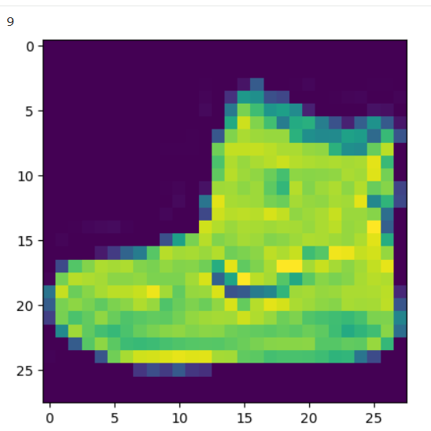
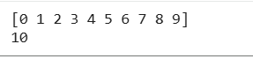
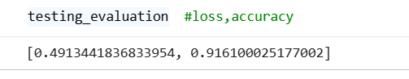
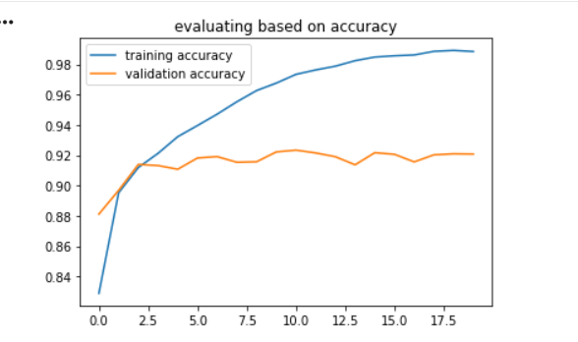
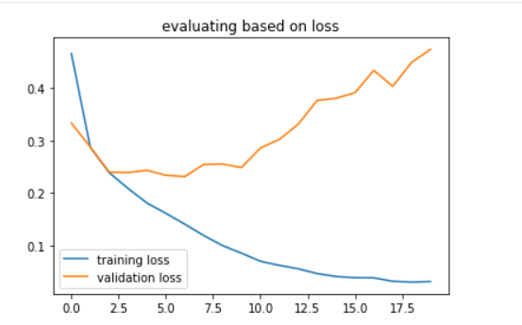

Pre Lab Exercise:
- What is the Convolution process? Explain, giving an example.
The convolution process is the core operation in a Convolutional Neural Network (CNN), where a small filter (kernel) slides over the input image and performs element-wise multiplication and summation to extract features.
It helps detect patterns such as edges, textures, and shapes.
How it works:
- A filter is placed over a part of the image;
- Perform element-wise multiplication;
- Sum all values to get one output value;
- Slide the filter across the image to produce a feature map.
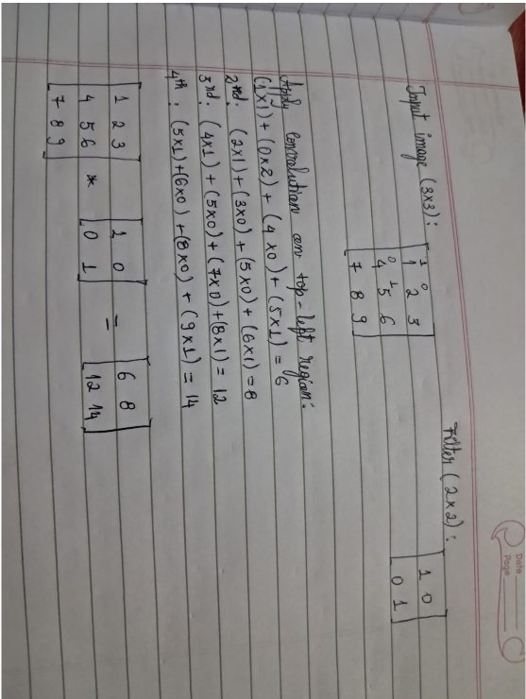
- What are the different layers in the CNN model?
The different layers in the CNN model are:
- Convolutional layer: applies filters to extract features, produces feature maps, and learns patterns.
- Pooling layer: reduces spatial size and keeps important information.
- Fully connected layer: converts extracted features into final predictions, performs classification.
- Activation layer: adds non-linearity, applied after convolution.
- What is the requirement of the pooling layer in the CNN model?
We require a pooling layer in the CNN model for:
- Dimensionality reduction;
- Faster computation;
- Noise reduction: removes irrelevant or noisy information.
- Translation invariance: helps the model recognize objects even if slightly shifted.

- What is the requirement of the use of the ReLU activation function after the convolution step?
The ReLU activation function after the convolution step is required for non-linearity introduction, to remove negative values, faster training, prevents vanishing gradients problem.

Observation and Result Analysis:
- Nature of the dataset
- Training Process without regularization
- After regularization in the training Process
- Observation over the Learning Curves

Post Lab Exercise:
- Why is CNN preferred over ANN for images?
ANNs have been used for image classification tasks, but they have some limitations. The main challenge in using ANNs for image classification is that they do not account for the spatial structure of images. They treat each pixel as an independent feature, which can lead to poor performance on tasks that require spatial reasoning, such as object recognition. That is why CNNs are preferred; they employ convolutional layers, which subject the input picture to several teachable filters. Each filter provides a feature map that indicates the locations of the features it has detected in the picture, such as an edge or texture.
CNNs are capable of learning hierarchical representations of the input picture, which is advantageous for transfer learning.
- Can CNN be applied to text data? If yes, then how? If not, then why?
Yes, CNN can be applied to text data.
- Convert text to vectors;
- Apply 1D convolution;
- Pooling layer
CNNs capture local patterns (n-grams) in text, which are useful for sentiment analysis, text classification, and spam detection.
However, CNN captures local context only, not long dependencies.
- What is the role of the dropout layer?
Dropout is a regularization technique used to prevent overfitting. During training, it randomly turns off (drops) some neurons.
Its role is to prevent neurons from becoming overly dependent, force the network to learn robust features, and act as if training multiple smaller networks.
- What will happen if maxpooling is replaced with minpooling?
Replacing maxpooling with minpooling in a CNN can lead:
- Zero activations: if the input data has zero activations, the output will also be zero, which can result in no learning as all gradients will be equal to zero;
- Feature extraction loss: maxpooling emphasizes the most prominent features, while minpooling may not capture as much information, potentially leading to a loss of important details in the data;
- Performance impact: the performance of the model may be affected, as the model may not be able to learn as effectively with minpooling as with maxpooling.

